St. John the Evangelist


Faith Formation
Lent 2026

The USCCB.org says, “Lent is a 40-day season of prayer, fasting, and almsgiving that begins on Ash Wednesday and ends at sundown on Holy Thursday. It's a period of preparation to celebrate the Lord's Resurrection at Easter. During Lent, we seek the Lord in prayer by reading Sacred Scripture; we serve by giving alms and we practice self-control through fasting.”

The items below are ideas to help grow closer to Jesus Christ
every day during the Lenten season and prepare for Easter Sunday.

(Visit each website by scanning the QR Code.)

The “Little Black Book” can be Amenapp.org
picked up in the church vestibule.

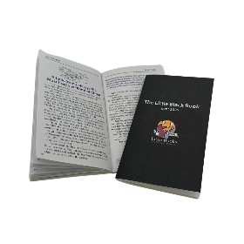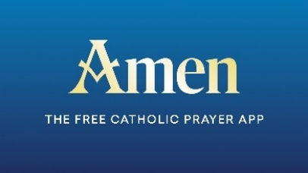

Daily.FORMED.org/lent CRSricebowl.org

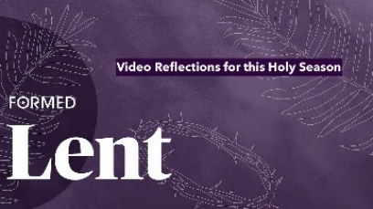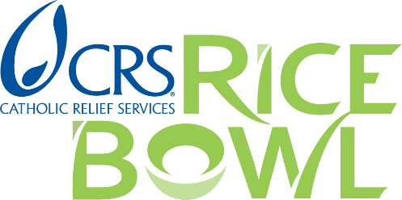

DynamicCatholic.com/lent Hallow.com/lent



“Lenten Pizza Nights”

On March 6 & 20, join other parishioners for fellowship and a pizza dinner.

The meal will take place from 5:00 PM to 7:00 PM in the school cafeteria.
A freewill offering will be accepted to support the “Faith Formation Team” Ministry.
Head over to the church after Pizza Night for Stations of the Cross.
(Please fill out your information on the clipboard on the Faith Formation Team table in the church vestibule by 7:00 PM the night before each Pizza Night so the correct number of pizzas can be ordered.)

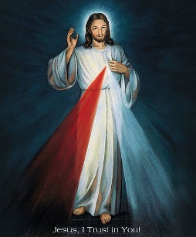
Divine Mercy Chaplet - Can you give Jesus an extra 15 minutes of your day? Join our community in praying the Divine Mercy Chaplet 15 minutes before each weekday Mass
and after all weekend Masses. Chaplet cards will be provided. We will join in a
powerful novena which begins on Good Friday and ends on Divine Mercy Sunday.
Jesus said, “It pleases me to grant everything souls ask of me by saying the chaplet.”

--------------------------------------------------------------------------------------------------------------------------------------------------------------------------------------------------------------------------------------------------------------------------------------------------------------------------------------------------------------------------------------------------------------------------------------------------------------------------------------------------

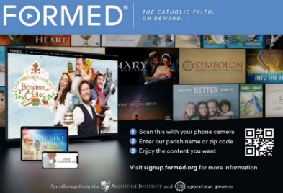

FORMED at SJE!

Diving into the beauty of the Faith has never been easier: at home, on the go, or from any Internet connected device. Discover thousands of books, audio talks, movies, documentaries, and studies... there is something for every member of the family to help them grow closer to Christ and His Church. Flyers are on a table in the church vestibule.

The following are offered on FORMED.

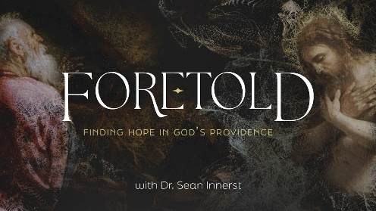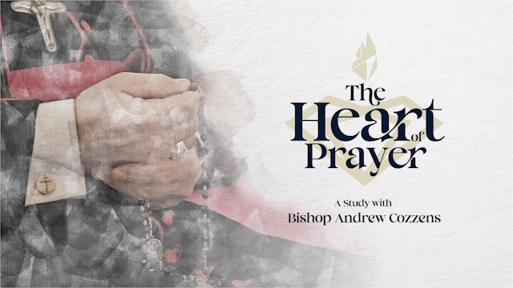

--------------------------------------------------------------------------------------------------------------------------------------------------------------------------------------------------------------------------------------------------------------------------------------------------------------------------------------------------------------------------------------------------------------------------------------------------------------------------------------------------

Mark Forrest presents “The Come Walk With Me.”
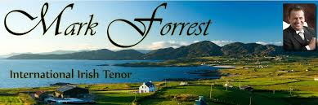
It is a time to reflect on your personal relationship with
Jesus Christ. During the Exposition of the Blessed Sacrament,
Mark will take you through an evening of music, reflection, and healing.
Take time with the Lord as he invites you on a closer walk with Him.
(Sunday, March 1; 7:00 PM to 9:00 PM; Church Sanctuary)

--------------------------------------------------------------------------------------------------------------------------------------------------------------------------------------------------------------------------------------------------------------------------------------------------------------------------------------------------------------------------------------------------------------------------------------------------------------------------------------------------

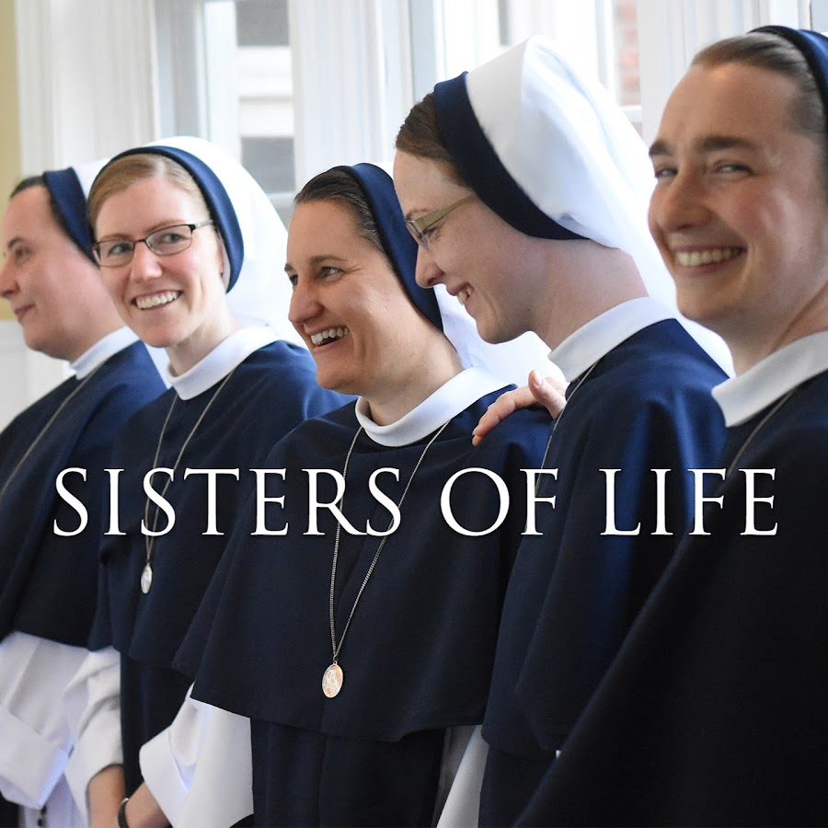

The Sisters of Life (sistersoflife.org) will be giving a talk about
“Finding Joy in the Midst of Suffering.” The talk will take place at 2:00 PM
followed by time for Adoration. This will lead into the 4:00 PM Vigil Mass.
(Saturday, March 7; 2:00 PM to 5:00 PM; Church Sanctuary)

--------------------------------------------------------------------------------------------------------------------------------------------------------------------------------------------------------------------------------------------------------------------------------------------------------------------------------------------------------------------------------------------------------------------------------------------------------------------------------------------------

"Ask a Priest & Seminarian Night"
is your chance to bring your questions, big or small, about Catholic faith, life, and practice.

Date: Thursday, February 26, 2026
Time: 7:00 PM to 8:30 PM
Location: St. John the Evangelist Church Sanctuary



